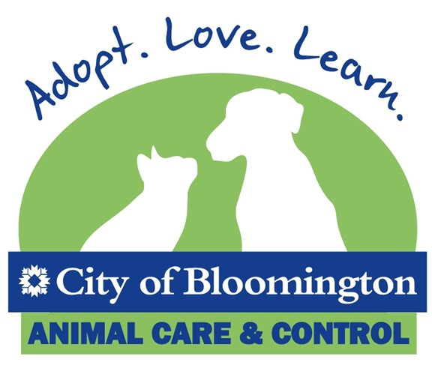

Dog Walking Training Material
  - Revised 10/30/23

Contents
Color Coding 2
Green Dogs 2
Yellow Dogs 2
Red Dogs 2
General Dog Walking Rules 3
Bite Case Procedure 6
Yellow Dog Training Info 7
Fearful Dogs Walking Tips 7
Dog/Gate Reactive Walking Tips 7
Jumpy/Mouthy Walking Tips 8
Volunteer Guidelines for the Borrow A Dog Program 9
Volunteer Criteria 9
Dog Criteria 9
Rules 9
Procedure 10

Thank you for volunteering to walk dogs here at the Bloomington Animal Shelter! This document includes information on how to walk/handle dogs safely. Please review it prior to your first shift. Have fun!

Color Coding
When you approach a kennel, please observe the color-coded tag on the kennel door so that you are prepared to use the appropriate walking strategies for that dog. These are the types of behaviors you can expect from dogs in green, yellow, and red-tagged kennels:

Green Dogs:

- May pull on leash slightly
- Will not attempt to approach other dog kennels
- Will not jump up or mouth leash repeatedly
- May need leash training skills or have mild fear in kennel
- Are easily food motivated and refocused
- Seek affection from people

Yellow Dogs:
- May pull on leash
- May be high energy and easily distracted
- May jump up or become overstimulated during play
- May pull toward kennel gates or other dogs while on leash
- May be very fearful in kennel
- May not overtly seek affection from people

Yellow Dog Subcategories: Fearful
Jumpy/Mouthy
Dog/Gate Reactivity

Red Dogs: (DO NOT WALK—STAFF HANDLING ONLY)
- May be mouthy with pressure
- May body slam/mount or jump at handler in yard
- May be hard to distract from fixation on other dogs
- May not focus on or seek attention from people
- May be highly dog reactive/exhibit fence fighting or snapping behaviors
- May have a history of aggression or bites

Some red-coded dogs cannot be walked by volunteers due to other behavioral challenges or age (if under 26 weeks).

Please let staff know if a dog behaves in a manner inconsistent with its color coding.
You may also speak with the following staff members in person or via email about any information or concerns you have regarding the behavior or safety of our dogs:

Jenny Gibson, Volunteer Program Director: xxx@bloomington.in.gov
Emily Herr, Outreach & Behavior Coordinator: xxx@bloomington.in.gov
Robyn Peffinger, Shelter Manager: xxx@bloomington.in.gov
Virgil Sauder, Shelter Director: xxx@bloomington.in.gov

General Dog Walking Rules
First, we will discuss the rules that apply to all dogs. After this section, we will delve deeper into strategies for yellow-coded dogs.

- If you arrive before 12 pm or volunteer on Wednesdays, please ring the white doorbell on the near-west side of the building (next to the double glass doors that say “Education Room”) to enter. If you arrive Mon/Tues/Thur/Fri/Sat/Sun after 12 pm, please enter at the front door.

- Dogs are currently housed in two sections of the building: the Stray Side, which houses all new dogs, Bite Quarantines, and some adoptable dogs, and the Adoptable Side, which houses only dogs that are ready to be adopted. You will be assigned to one regular shift on either the Adoptable or the Stray side.

- On the Adoptable Side, all dogs are housed in one hallway. Dog Walkers may start from either end but should travel to the closest yard available to avoid stressing the other dogs. Please take dogs from the OUTSIDE of the kennels for safety and to reduce reactivity and stress. Check the three inside kennels for dogs over six months (26 weeks) old.

- On the Stray Side, there are five sections where dogs are housed. These areas are: Dog Rooms A, B, C, D, and the Dog Isolation Room. All the dog rooms are in one hallway, except for the Dog Isolation Room, which is a smaller room near the northeast corner of the building. Staff will walk dogs in the Dog Isolation Room because this room is often used to quarantine illness.

- Walking Areas:

  - Adoptable dogs can be walked in the green-fenced Adoptable Yards, as well as the white-fenced yard nearest the Adoptable Side.
  - Stray dogs in Stray Rooms A, B, and C can be walked in the yard outside those rooms. Stray dogs in Dog Room D must be walked in the yard outside that room.

- Please check the kennel doors to identify what color the dog has been coded and refer to the corresponding section of this document for tips on how to safely walk the dog.

- Dogs must be at least six months old (26 weeks) to be taken outside. Puppies younger than six months old have not yet received all the vaccines needed to prevent parvovirus and are at serious risk of disease.

- Please never touch puppies on the Stray Side of the building. Because they are vulnerable to parvovirus and upper respiratory disease, any contact with our hands or clothing can transmit a life-threatening disease to these puppies. You may visit puppies on the Adoptable Side in a visitation room.

- Dog Walkers and Canine Stewards will have their own Dog Walking Pack complete with a clip leash, slip leash, poo bag holder/poo bags, and a treat pouch. When you pick up your pack (usually at your first shift) you will sign the sheet on the table in the Volunteer Lounge stating you will return these items if/when you stop volunteering with us. Please sign next to your printed name.

- It is easiest to get the dogs out of the kennels with a slip leash. Slip leashes MUST be used for yellow Fearful dogs. You may transfer to a clip leash once in the yard, if needed. Clip leashes may be helpful for Dog/Gate Reactive dogs or Jumpy/Mouthy dogs so they can drag the leash and you can grab it if needed. If there is no indication on the kennel that the dog should not be let off leash, you may do so and let her run and play!

- Please read kennel cards and all signs posted on kennels for any relevant information.

  - On the Stray Side, you will need to check for signs that say, “DO NOT TOUCH: Quarantined for Infectious Disease Risk,” “Do Not Walk,” “Staff Only,” “Bite Case,” and any red signs in general. None of these dogs can be touched or walked by a volunteer. There may also be paper signs that identify a specific need for that dog, such as “Please keep me on a leash,” or “I am nervous, please go slow with me.”
  - On the Adoptable Side, please read the kennel cards and any printed or laminated signs for information on each dog. If the kennel is covered with a blanket for stress reduction, please move it to read all pertinent information.

- On the Adoptable Side, please take the dogs from the outside kennel door regularly. However, if the kennel staff is cleaning during your shift, you will have to take dogs from the side where the staff member is not working. Please also check the three small inside kennels to see if those dogs are over six months old (26 weeks) and walk them if so.

- When taking dogs from the kennels on the Adoptable Side, you must always close the kennel door securely. Since the kennels have two sides, there is a high possibility that a dog can get loose if we do not close both doors. Also, when you return a dog to a kennel, give the dog a treat for entering the kennel, close the door, and replace the padlock. Replacing the padlock will prevent the dog from jumping up and knocking the door open, or worse, hitting you in the head with the door. Please see the following image for a clearer explanation:

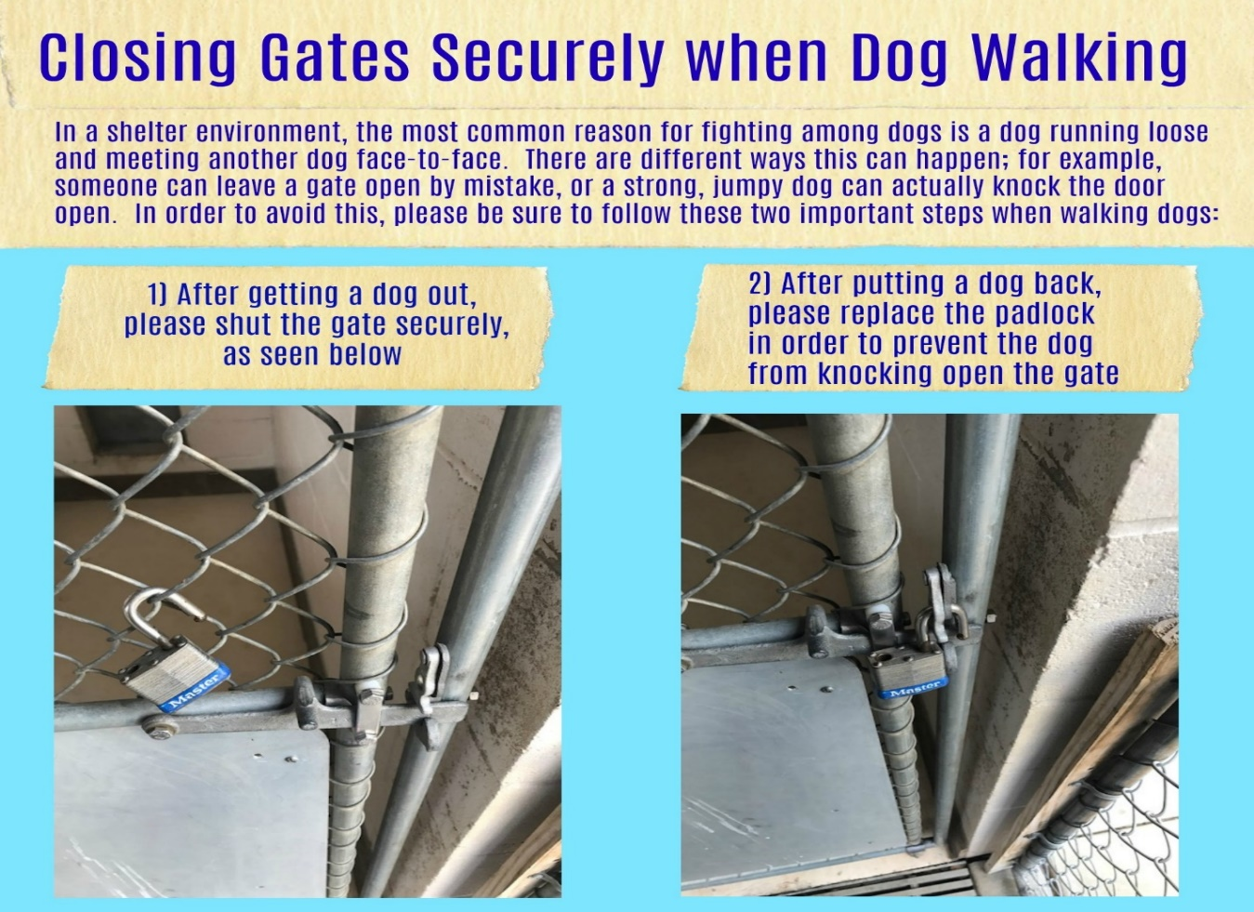

- The kennels on the Stray Side are inside only, so please be sure to close the door securely when you remove a dog. There should be some type of padlock, carabiner, etc., in both doors to hold them closed. These doors are very easy for dogs to kick open, so please replace the padlocks or other metal fasteners when you put the dog back in.

- All dogs MUST be kept on a short leash, with your hand next to your hip, on the opposite side of where the other dogs are kenneled. Please walk dogs quickly past the kennels and into the yard. If you have dogs on both sides, stay as close to the middle as possible with the dog and move quickly.

- Please keep the dog you are walking away from all other dogs and never allow dogs to touch noses. If dogs are introduced inappropriately, it is very possible that they will engage physically and harm each other. Please watch for other dogs/animals at all times, especially when exiting or entering a hallway, door, or gate.

- Please never allow dogs to bark/growl at each other through the kennel doors or fences. This is known as fence fighting, and can create lasting aggression between dogs. If a dog begins fence fighting, DO NOT TOUCH the dog’s collar, harness, or body. If you do, the dog may redirect its energy onto your hands or body. Please pull the dog away using only the leash, and if that doesn’t work, ask staff for help.

- Please do not place any part of your body in between two fence-fighting dogs; only pull them apart with a leash. If you get in between the dogs, you will be bitten. If you can’t pull them away using your leash, find staff for help. If a dog gets loose from you, ask the staff for help! Stay safe and let the staff retrieve the dog.

- If a dog gets loose and gets into a fight with another dog, DO NOT ATTEMPT TO INTERVENE! Do not reach into the fight or touch the dogs’ bodies; you will get hurt. Ask staff for help!

- Only one dog should be in a yard at a time, unless the dogs live in the same kennel. If so, it’s up to you if you want to walk them one at a time or together.

- Please do not play tug of war with any of the dogs. This game can get out of control quickly, and your hands may get bitten. You may see Behavior Staff do this, but they are working on specific training and behaviors. Our Behavior Intern, Emily Dunham, works with dogs in the Behavior Program from 10 am-2 pm, so she may be in the walking areas, but she is working on specific behavior modifications and not “walking” dogs.

- If a dog gets over aroused in the yard, and you cannot leash him and put him back into the kennel, throw treats/toys away from you to distract him, leave the yard, and get help.

- Please use the plastic bags located in the yards to pick up poo and drop it into the trashcans or buckets in the yards.

- Try to offer ten minutes per dog. However, just do the best you can. You are not expected to walk dogs that make you uncomfortable or to stay longer than your shift time. Please know your physical limits and do not walk a dog that is too big or powerful for you. Also, the number of dogs consistently fluctuates, so you may not have the time/energy to get to all of them. Just do your best and don’t overdo it! (Ask Jenny for help if needed!)

- Please return dogs to the proper kennel to prevent disease transmission and stress.

- Please alert staff of any health or behavioral issues you notice in the dogs while walking them.

- There is a clipboard on the table in the Volunteer Lounge where you can make notes about animals as well. This is a good place to note if a dog plays fetch, knows tricks, etc. Anything helps, but be sure to report anything worrisome directly to staff.

- Please sanitize your hands after walking each dog to prevent disease transmission. Sanitizer dispensers are located on the walls and outside the kennels.

- On the Adoptable Side, your yard may be needed for a visitation with a potential adopter. In this instance, you can use the white yard to the west of the kennels or just take a break until the visitor is finished. You can always relax with a kitty or bunny! Just be sure to wash your hands well so you don’t smell like a big doggy!

- If you are bitten and the dog (or other animal) draws blood, YOU MUST REPORT IT for your safety and the safety of others.

This is the Bite Case Procedure:
- Alert a staff member immediately. Administrative assistants will always be at the front desk, so you can report there.
- We will have you wash the wound with soap and water, and bandage it as needed. There are medical supplies at the front desk and on the bookshelf in Jenny’s office.
- We will need to fill out what is called a Bite Report, where we will record your details, the dog’s information, and the specific details of the bite. An animal control officer or staff member will ask to view the bite to judge the severity of it.
- Seek medical attention for your injury as soon as possible. The wound cleaner most often used to prevent bites from infection is called chlorhexidine gluconate (Hibiclens). It is usually suggested to use this cleaner twice a day in conjunction with antibiotics. Watch the injury for signs of infection like seeping, swelling, excessive pain, or red lines extending from the wound. Seek medical attention if you suspect infection.
- If you are bitten and Jenny is not present, please email her about the incident so she can follow up.
- The dog will be placed on a ten day Bite Quarantine to observe for rabies symptoms, per state law.

Yellow Dog Training Info
These are techniques to use when walking dogs coded as Yellow: Fearful, Yellow: Dog/Gate Reactive and Yellow: Jumpy/Mouthy.

Fearful Dogs Walking Tips:

Please only use a slip leash with dogs marked as “Fearful,” as they may have neck/body sensitivity.

Do:
- Approach very slowly.
- Make your body as low as possible and turn to the side.
- Allow the dog to sniff and explore the leash before use.
- Slip the leash under the chin instead of going over the head.
- Pet under the chin, on the chest, or down the back instead of on the head.
- Lead with super yummy treats and treat often.
- Crouch down and encourage the dog with a calm voice and treats if he stalls when walking.
- Give the dog some space and try again in a few minutes if he does not come out of the kennel on the first attempt.
- Toss treats into kennels when walking by fearful dogs.
If you are still having difficulty getting the dog out of the kennel: unless otherwise noted, you may enter the kennel, squat, and turn away from the dog. Then, allow him to approach you and slowly leash him under the chin.

Do NOT:
- Corner the dog, always allow options for retreat.
- Make direct eye contact.
- Force the dog to come out of the kennel.
- Use rough handling or pat or pet on the head.
- Make sudden movements.
- Yank or pull the dog along or out of the kennel.

Dog/Gate Reactive Walking Tips:

Do:
- Require four feet on the ground before opening the gate.
- Walk away and try again later if the dog is too aroused.
- Use a very short-leashed walking approach.
- Constantly talk to the dog and treat her to retain her focus on you and not her surroundings while walking to a yard.
- Know your limits, don’t be afraid to say no. If a dog is too much, let staff know. It’s always okay to leave a dog in a yard to keep yourself safe.
- ONLY let a dog off leash to run and play when all four feet are on the ground.
- Keep walking and directing the dog’s attention away from a dog or kennel she is pulling toward. You may hold a treat to your face to direct her to listen to you.

Do NOT:
- Allow the dog to lead the way on the walk.
- Stop moving and allow dogs to engage through barriers.
- Attempt to retrieve a reactive dog on your own. If you lose control of the dog, GET STAFF to help.
- Stick your hands/body in between the dog and the fence/gate if there is reactivity/fence fighting.
- Touch a dog engaged in fence fighting. The dog may redirect his energy on your hands or body. If you cannot pull the dog away with a leash, ask staff for help!
- Feel guilty if you cannot safely walk a dog.

Jumpy/Mouthy Walking Tips:

Do:
- Require four feet on the ground before opening the gate.
- Walk away from the kennel at any point and try again later if the dog is too aroused.
- Constantly talk to the dog and treat him to retain his focus on you and not his surroundings while walking to a yard.
- Hurry, hurry, hurry through areas where other dogs are.
- Only let a dog off leash to run and play when he has four feet on the ground.
- Yell “Ouch!” in a high-pitched voice if the dog is mouthing you or takes treats too roughly.
- Reward calm behaviors and try to teach “sit” as an alternative to undesirable behaviors being displayed. Give treats when the dog has all four feet on the ground.
- Turn away and ignore when a dog jumps on you. If this doesn’t help, re-leash the dog and walk on leash only.
- Stand on the leash for a moment if the dog keeps jumping. Then try to walk calmly on leash again.
- Stand on the leash for a moment if the dog tries to “mount.” Then try to walk calmly on leash again.
- Return the dog to the kennel if he is continuously jumping/mouthing/mounting.
- Throw treats away from you and exit the yard if the dog becomes over aroused and is not listening to you or is mouthing/jumping/body slamming. GET STAFF RIGHT AWAY!
- Spend time working with the dog at the kennel gate even if you can’t get him out at that time. This is enrichment too!
- Ask for help when you need it!

Do NOT:
- Walk a dog that makes you feel uncomfortable.
- Allow the dog to continuously mouth or jump on you.
- Allow interactions between you and the dog to escalate—if anything makes you uncomfortable, take the dog back in or ask for help to do so.
- Feel guilty if you cannot safely walk a dog.

Borrow A Dog!
Now that you have been trained to safely handle dogs, you can Borrow A Dog! Participation in this program should be in addition to your scheduled Dog Walking shift, but it is great fun! If you would like to Borrow A Dog, please read the following information and follow the outlined procedure carefully.

Volunteer Guidelines for the Borrow A Dog Program
This program allows regular volunteers to take a dog offsite in order to provide the dog with enrichment, exercise, and possibly to meet a potential adopter! Please read the following rules and guidelines for keeping both volunteers and dogs safe.

Volunteer Criteria
To borrow a dog, volunteers must be:
- Active volunteers
- At least sixteen years of age
- Trained in Dog Walking (Other volunteers may participate, but must speak with the Volunteer Program Director for more information)
- Comfortable transporting dogs in their vehicles
- Physically able to control the dog they choose
- Dressed in appropriate clothes and footwear

Dog Criteria
To participate, dogs must:
- Be at least six months of age (26 weeks)
- Already be altered (spayed/neutered)
- Be available for adoption
- Be free from any major behavioral challenges that would inhibit a safe trip (extreme reactivity, etc.)
- Be on the Borrow A Dog list in the Furry Follow-Up newsletter (posted in the Volunteer Lounge)

If the dog you would like to borrow is NOT on the Borrow A Dog list, please ask a manager for approval before taking the dog you are interested in. The only exceptions to this rule are dogs in the Club Underdog program, which the Behavior Department will approve, or a foster volunteer coming in to take out a dog that they have previously fostered.

Rules
- Walk only one shelter dog at a time. An exception can be made if two dogs are kenneled together, and you and another volunteer want to walk together. Only one dog per handler.

- Do not walk your own personal dogs together with the shelter dog. This is to protect your dog from exposure to possible illnesses and for the safety of all involved.

- Never let the shelter dog off leash or let it interact with other dogs. Therefore, do not go to dog parks.

- When you arrive at your location, make sure to have a firm grip on the leash before opening the vehicle door to prevent the dog from bolting out.

- Use plastic bags to clean up after the dog, respect private property, and keep the shelter dog from jumping on passersby. We want the dogs to be ambassadors for the shelter.

- Keep your attention focused on the dog. Pay attention to body language and how the dog reacts to his surroundings.

- Be cautious about children. Do not let children put their faces in the shelter dog’s face or attempt to hug the shelter dog.

- This is a great opportunity to showcase our dogs to potential adopters, so feel free to encourage people to call us at 812-349-3492 if they are interested in adopting. You can also let them know we have a current list of available animals on our website: https://www.bloomington.in.gov/animal-shelter.

- If people have questions you can’t answer or want to know more about the shelter, they may call the front desk at 812-349-3492.

Procedure
- Choose a dog from the Borrow A Dog list.

- Fill out the Borrow A Dog sign out sheet on the red clipboard so that staff know what dog you have taken, where you are going, and how to contact you in case someone comes in to meet that dog.

- Take an “I am on an Outing with a Volunteer…” sign and place it on the dog’s kennel, so staff and visitors know that the dog is out temporarily and has not been stolen.

- Grab an “Adopt Me” vest to promote your dog friend! Vests are in the plastic container near the bulletin board in the Volunteer Lounge. They are NOT secure, so just fit one as well as possible and clip the leash to the dog’s collar for safety. Leashes can be found on Jenny’s door if there are none in the Volunteer Lounge.

- Read or take a photo of the dog’s kennel card so you may share the dog’s information with anyone interested.

- Don’t forget treats, poo bags, and a slip leash (in case the clip leash breaks).

- Take the dog on a fun adventure but be sure to follow all the safety guidelines.

- You must return to the shelter at least fifteen minutes before closing time. These are the hours available for volunteers to Borrow A Dog (please note these are not our hours open to the public):
- Monday-Friday: 8:30 am-4:45 pm

- Saturday-Sunday: 8:30 am-3:45 pm

- When you return:
- Sign back in on the clipboard.
- Take the dog back to the kennel and remove the “Adopt Me” vest and leash. Throw these in the blue tub in the Volunteer Lounge for cleaning.
- Remove the “I am on an Outing with a Volunteer…” sign from the outside of the kennel and put it back in the Volunteer Lounge.

- If you would like to send an email to Volunteer Program Director Jenny Gibson regarding how the dog did on your Borrow A Dog journey, please do. Jenny can be reached at xxx@bloomington.in.gov. This information can often be helpful for potential adopters.

- If you noticed any areas of concern regarding how the dog behaved, please be sure to let staff know before you leave and email the Volunteer Program Director as well.

- If a bite incident occurs (either human or animal), please call the animal shelter immediately at our emergency number, XXX-XXX-XXXX, to report the incident. Never give this number out to the public. If you cannot reach someone at the shelter, get the name and phone number of the other party, tell them the shelter will call them, and return to the shelter immediately. There are specific state and local laws pertaining to bites that must be followed so it is imperative that these are reported to staff immediately.

